Student ID OR Photo ID

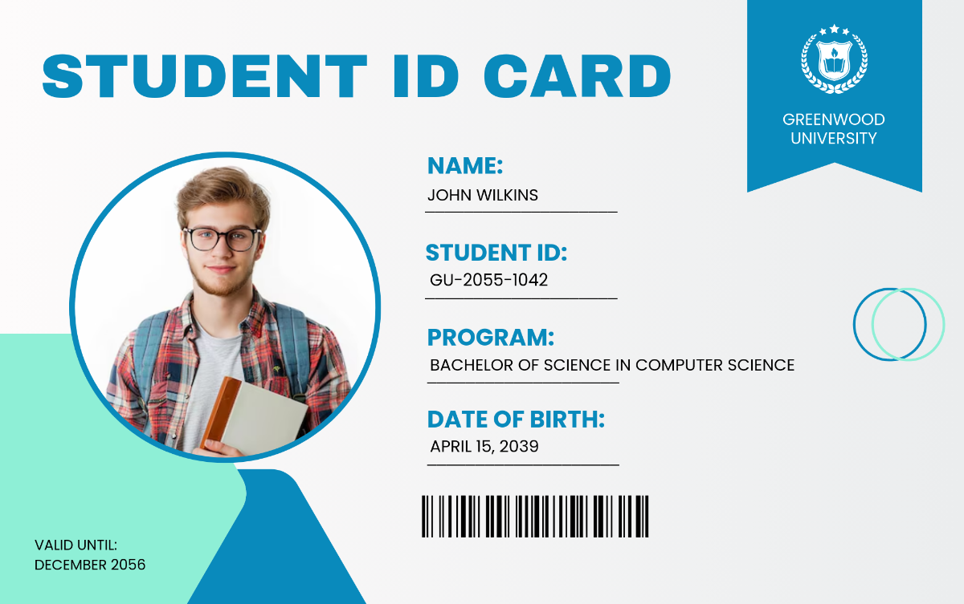

BLANK

Australian Police Check (all students)
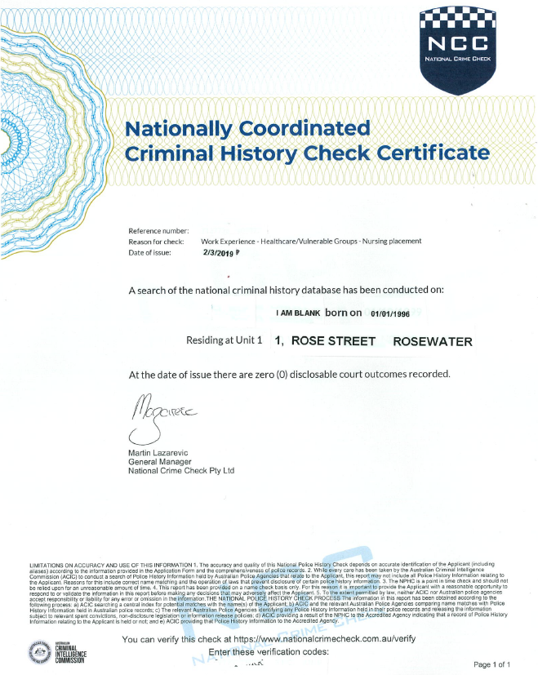
100 TREE STREET, NOWHERE, NSW 12345
Authorised By:
M. Point
10/11/2021
J.D BLANK
Authorised By:
M. Point
EXAMPLE ONLY

NATIONAL POLICE CHECK

Only if International student
Overseas Police Check OR Overseas Statutory Declaration
From Appendix 3- link here: https://www.heti.nsw.gov.au/__data/assets/pdf_file/0007/473173/Overseas-Student-Statutory-Declaration.pdf

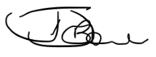
Undertaking/Declaration Form 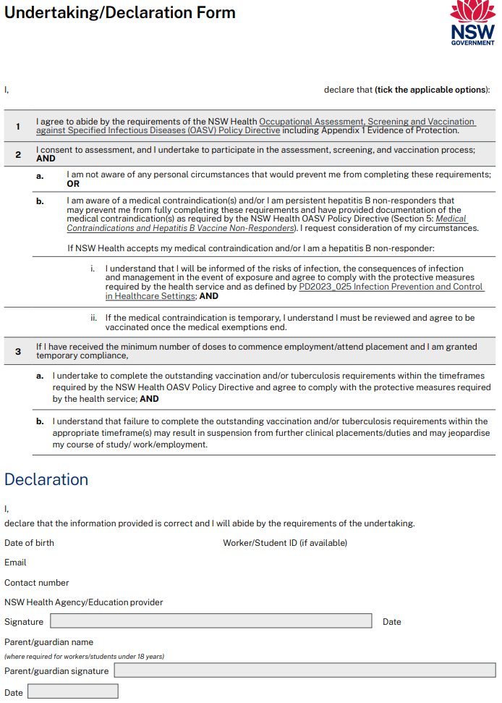
sign
University email
01/01/1996
Authorised By:
M. Point
PRINT YOUR NAME HERE
PRINT YOUR NAME HERE
Tick the appropriate option for question 2. either a. or b.

NSW Health Code of Conduct Agreement
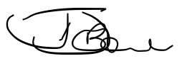
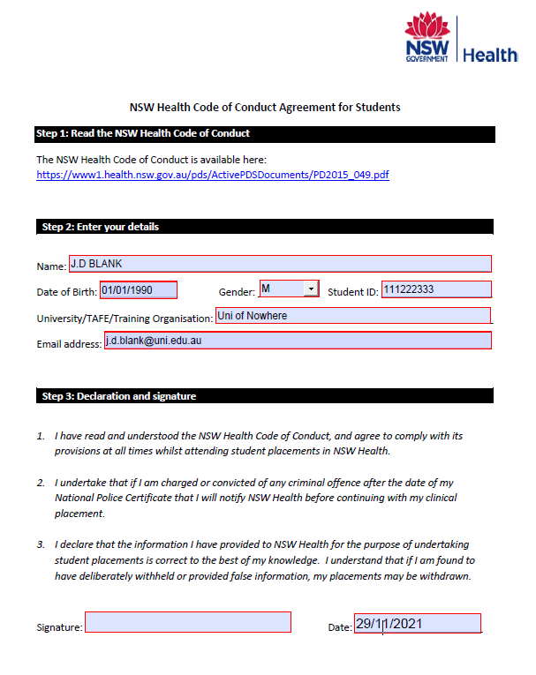
01/01/1996
Authorised By:
M. Point
Ensure all sections completed- please use Uni email. Date and sign bottom

Completed TB Assessment Tool
Complete the three pages

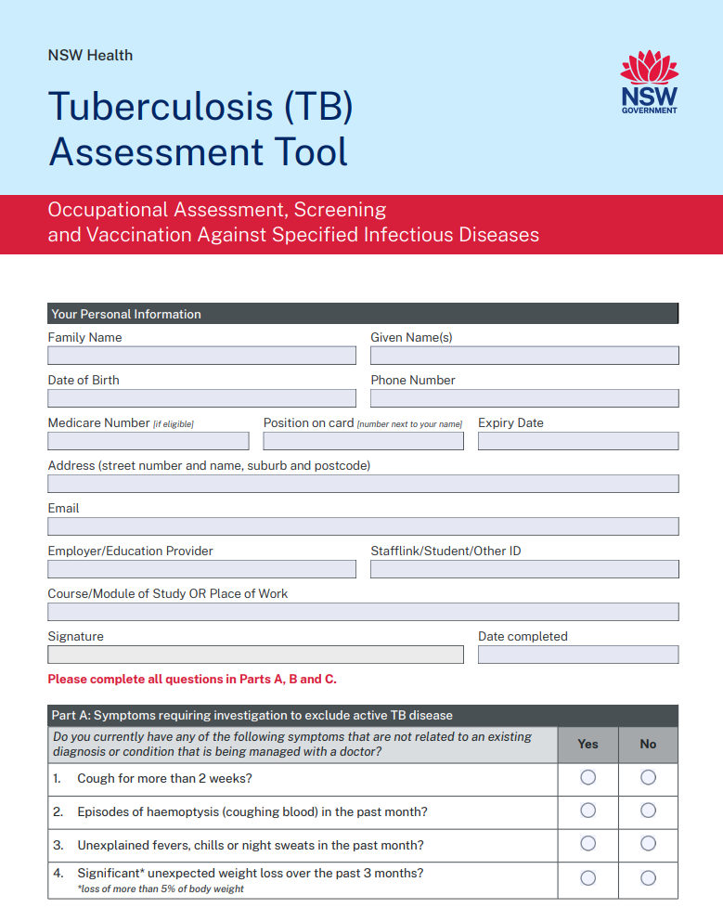
FILL IN ALL DETAILS

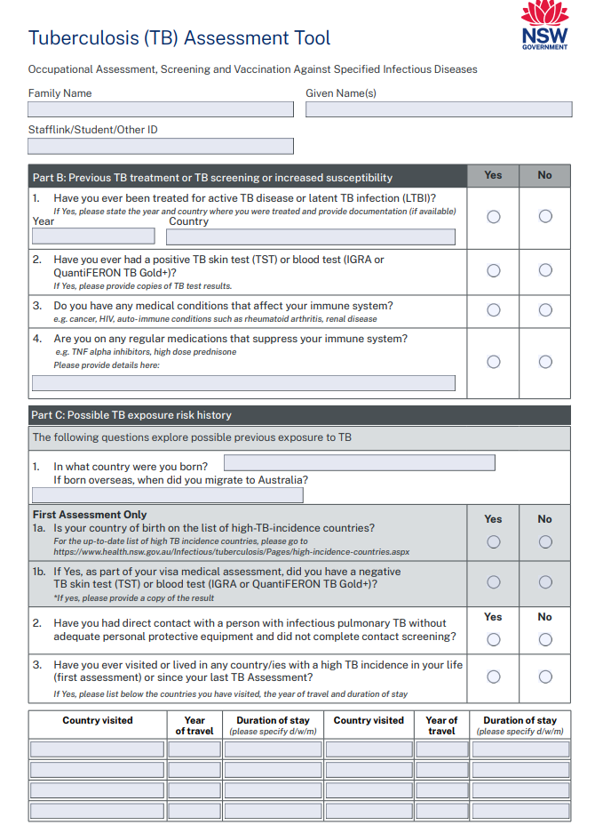
Please read this carefully. You may have visited multiple high incidence TB countries and cumulatively this travel could be 3 months.
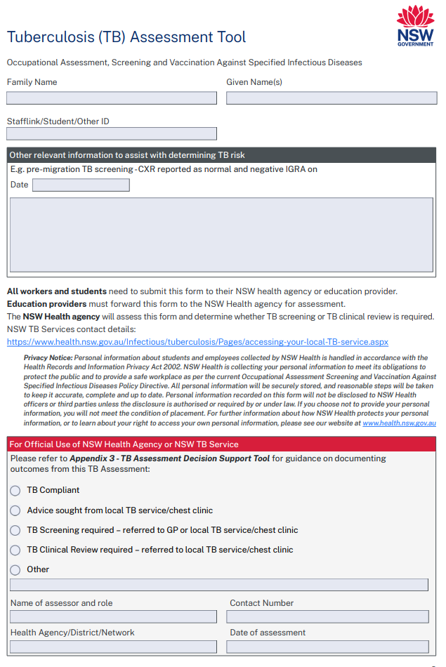

Vaccination and Immunisation evidence including any childhood vaccination card, TB testing &/or TB clinical review documentation
Only a GP or Immunisation Nurse can fill in this ‘Vaccination Record Card’ using evidence sighted from your IHS or other immunisation records. The GP or RN must stamp each entry with practice stamp
A Print RN
NMW000000234

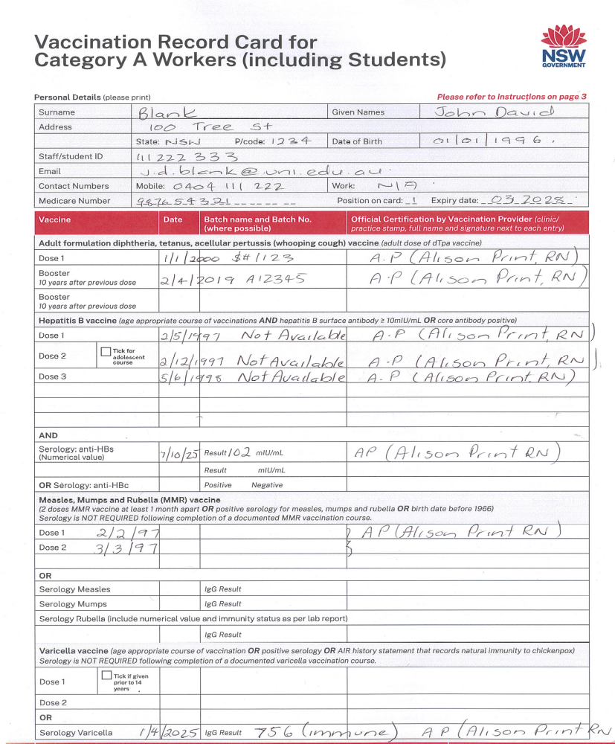
A Print RN
NMW000000234

A Print RN
NMW000000234

A Print RN
NMW000000234

A Print RN
NMW000000234

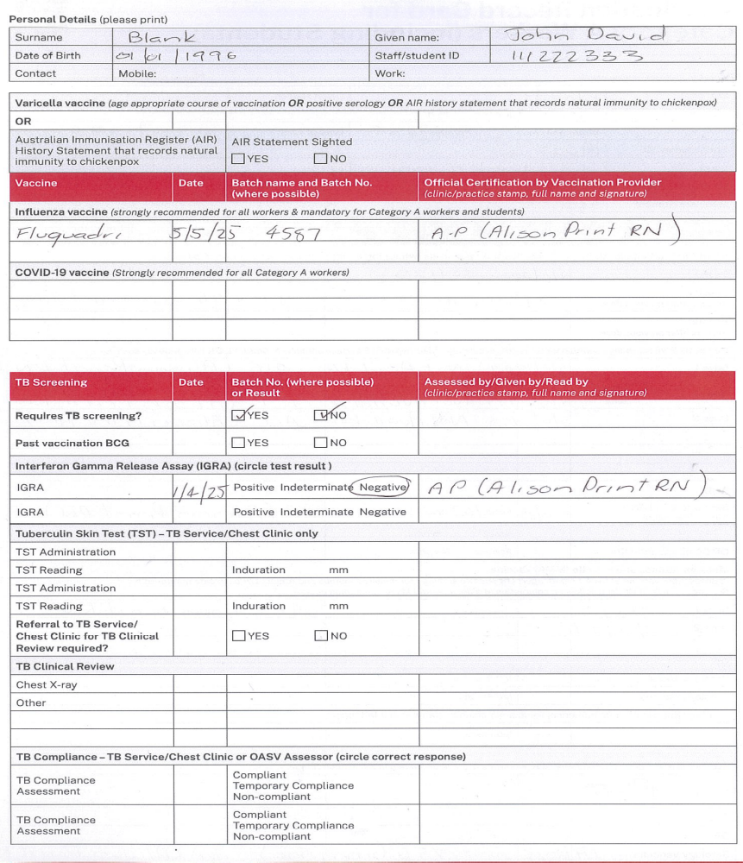
A Print RN
NMW000000234

A Print RN
NMW000000234

Please note- there may be a few pieces of vaccination evidence including serology reports. Ensure IHI has been removed from Australian immunisation Records

Immunisation History Statement (IHS)

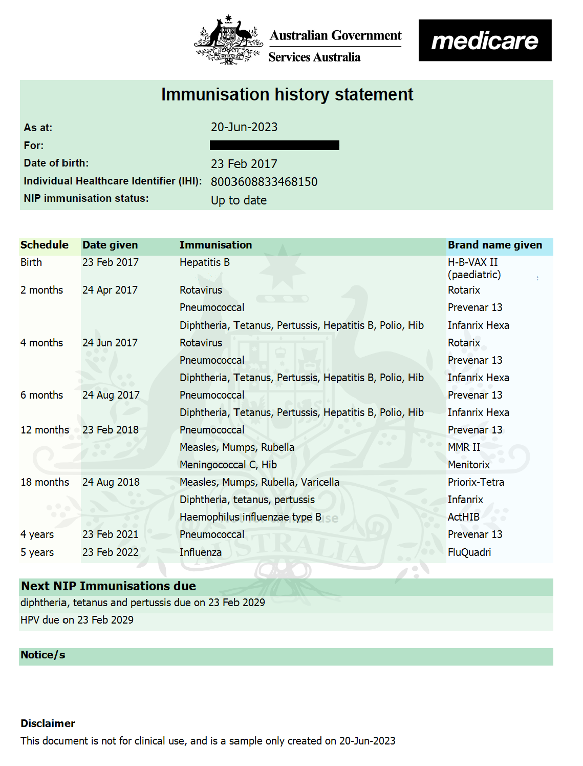

This link will help you find your Immunisation History Statement
Medicare online account help - Get an immunisation history statement - Services Australia

Additional Supporting Immunisation or TB testing documents if applicable

LAB REPORT
Patient Name: | I.AM.BLANK
ID Reference: | 00011212325458
Test: | Rubella  EXAMPLE ONLY
Requesting Dr: | Dr A.B
Collection Date: | 1/1/2019
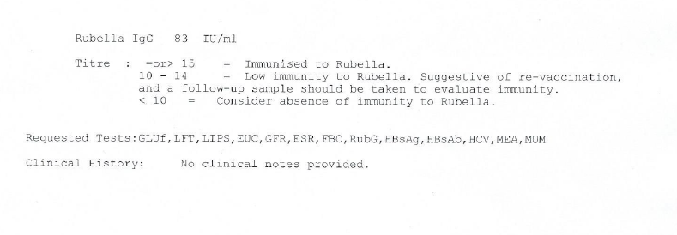

LAB REPORT
Patient Name: | I.AM.BLANK
ID Reference: | 00011212325459
Test: | Interferon gamma release assay test (IGRA test)  EXAMPLE ONLY
Requesting Dr: | Dr A.B
Collection Date: | 2/12/2021
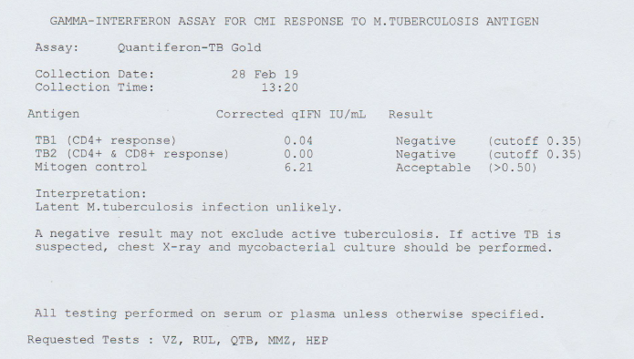
2/12/2021

ONLY COMPLETE THIS FORM IF YOU HAVE NO EVIDENCE OF HEPATITIS B VACCINATION BUT HAVE DEFINITELY COMPLETED A COURSE OF AGE- APPROPRIATE HEPATITIS B VACCINATION.
